STADIS LOGO.tif

Created by

International Micro Systems

A Guide for Installing, Configuring and Operating STADIS on Retail Pro POS

Contents

1.1 2

1.2 Introduction 3

1.3 Setup 3

1.4 Configuration 4

1.5 Procedure for Redeeming with a STADIS-Based Tender 5

1.6 Receipt Design 11

1.7 Balance Check Program 12

1.8 Configuration Information for Retail Pro Plug-in. 14

## Executive Overview

## Introduction

The POS interface has been developed to be as simple and clean as possible. We understand the need to make our applications user-friendly and we understand the benefits that they create.

The purpose of the POS interface is to give the user the resources necessary to accept the variety of STADIS tenders available to our clients. This includes, but is not limited to, Gift Cards, Coupons and Tickets.

## Setup

Before install make sure that you have the following applications on your machine:

1) .NET Framework 2.0

**Required Files:**

The following files should be automatically copied to their corresponding directory after running the install.bat application. This considers your Retail Pro path as C:\imspos\retail8. If your path is different than C:\imspos\retail8, please edit this document and the install.bat file accordingly.

|  |  |  |  |
| --- | --- | --- | --- |
|  | **File Name** | **Description** | **Target Location** |
| 1. | StadisTicketButton.bpl | Delphi Plug in Program for Redeem | C:\imspos\retail8\plugins |
| 2. | StadisConfiguration.exe | Delphi plug in configuration tool | C:\imspos\retail8 |
| 3. | StadisNETDll.tlb | .NET interop TLB File | C:\windows\system32 |
| 4. | StadisNETDll.dll | STADIS (COM+ .NET Dll) | C:\windows\system32 |
| 5. | StadisCOM.dll | STADIS COM Dll | C:\windows\system32 |
| 6. | StadisCOM2.dll | STADIS COM2 Dll | C:\windows\system32 |
| 7. | StadisCOM3.dll | STADIS COM3 Dll | C:\windows\system32 |
| 8. | IssueGiftCard.bpl | Delphi Plug in Program for Issue | C:\imspos\retail8\plugins |
| 9. | ReturnGiftCard.bpl | Delphi Plug in Program for Returns | C:\imspos\retail8\plugins |
| 10. | Noimage.jpg | Blank image file – may be replaced | C:\imspos\images |
| 11 | Stadis32.jpg(gif)(bmp) | Stadis Logos for Sidebar | C:\imspos\images |
| 12 | Usermenu.ini | Retail Pro Sidebar settings | C:\imspos\retail8\rpro |
| 13. | Configuration.ini | Encrypted configuration file | C:\imspos\retail8 |
| 14. | 40 Col.Rpt | Receipt report file | C:\imspos\retail8\Rpro\Design\DocDesigns\Receipt |
| 15. | 40 Col.Vbs | Receipt report supported VB script file | C:\imspos\retail8\Rpro\Design\DocDesigns\Receipt |
| 16. | ReceiptRTISchema.XML | Receipt field detail XML file | C:\imspos\retail8\Rpro\Design\RTISchema |
| 17. | Register.com | Register the assembly file | C:\windows\system32 |
| 18. | vcls\*.* | System files for Retail Pro Plugins | C:\windows\system32 |
| 19. | UpdateStadisPlugin.bat | Batch File used for Updating Plugin | C:\Documents and Settings\All Users\Start Menu |
| 20. | StadisBalanceCheck.exe.config | Config file Balance Check Program | C:\imspos\STADISBalanceCheck |
| 21. | SetupBCP.exe | Installs Stadis Balance Check Program | C:\imspos\BalanceCheck |

**Step1 – Copy files to their directories and register StadisCOM.dll**

You must be logged in as an administrator prior to installing any plug-ins or files listed in this document. Double-click the install.bat file. A prompt should display stating that the operation was successful. Click ‘OK’. The operations on the screen will continue until prompted to press a key to continue. Press any key.

**Step3 – Configuration Settings**

Set the configuration files by using the Stadisconfiguration.exe file located in the C:\imspos\retail8 directory.

## Configuration

**Utilizing the STADISConfiguration.exe application**

Below is a screenshot of the STADISConfiguration.exe program. This application creates a configuation.ini file which holds all of the settings for the Retail Pro Plug-ins. Greater detail will be given under the following screenshot.

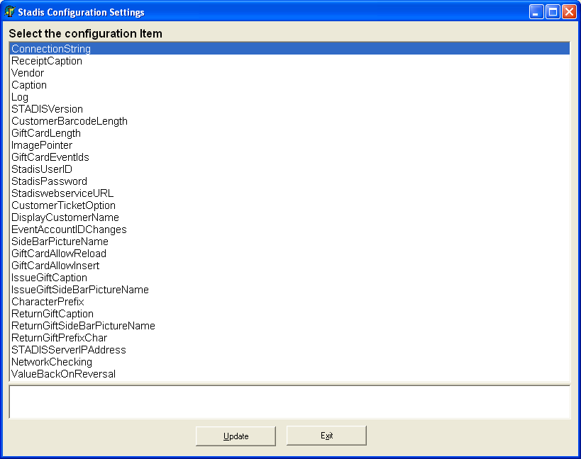

|  |  |  |  |
| --- | --- | --- | --- |
|  | **Setting Name** | **Description** | **Setting Example** |
| 1. | Connection String | Only applicable in older versions of STADIS – Direct DB Connection | N/A |
| 2. | ReceiptCaption | Caption placed at the bottom of the Receipt above card usage lines | Gift Card Rem Amt |
| 3. | Vendor | Name of the Vendor for Retail | RETAIL |
| 4. | Caption | Caption on SideBar of tender screen for redeem Plug-in | Redeem Gift Card |
| 5. | Log | Used for troubleshooting | OFF |
| 6. | StadisVersion | Declares the version of STADIS | 3 |
| 7. | CustomerBarcodeLength | Length of digits that Redeem Plug-in requires | 0(any), 12, 14, etc. |
| 8. | GiftCardLength | Length of digits that Issue Plug-in requires | 0(any), 12, 14, etc. |
| 9. | ImagePointer | Specifies the image used for the Issue and redeem Plug-ins | Image.jpg |
| 10. | GiftCardEventIds | Declares which eventid is used for Gift Cards for receipt printing | 6666 |
| 11 | StadisUserID | Logon for STADIS V3 | User1 |
| 12 | StadisPassword | Password for STADIS V3 | P@$$w0rd |
| 13. | StadiswebserviceURL | Pointer to the location of the WebService | http://IP/Stadis/Stadis.asmx |
| 14. | CustomerTicketOption | Triggers the pop-up for tracking all tickets prior to tender screen | NO |
| 15. | DisplayCustomerName | Currently not used | NO |
| 16. | EventAccountIDChanges | Used for V1 or V2 to put a hold on an account (mixed-mode) | NO |
| 17. | SideBarPictureName | Name for the image displayed in SideBar for Redeem - Plugin Folder | Stadis32.bmp |
| 18. | GiftCardAllowReload | Allow the reloading of value through the issue Plug-in | NO |
| 19. | GiftCardAllowInsert | Allow the creation of New Gift Cards through the issue plug-in | YES |
| 20. | IssueGiftCaption | Caption displayed next to the Issue Gift Card Plug-in | Issue Gift Card |
| 21. | IssueGiftSideBarPict… | Name for the image displayed in SideBar for Issue – Plugin Folder | Stadis32.bmp |
| 22. | CharacterPrefix | Used for scanning Gift Cards – Starts with special character first? | YES |
| 23. | ReturnGiftCaption | Caption displayed next to the Return Gift Card Plug-in | Issue Return Card |
| 24. | ReturnGiftSideBarPict… | Name for the image displayed in SideBar for Issue | Stadis32.bmp |
| 25. | ReturnGiftPrefixChar | Used for scanning Gift Cards – Starts with special character first? | YES |
| 26. | STADISServerIPAddress | IP address of Server Hosting STADIS. | 10.10.10.10 |
| 27. | NetworkChecking | Checks to see if the machine can ping the Server | NO |
| 28. | ValuebackOnReversal | If a STADIS tender is used, and receipt reversed, put money back on | NO |

Note: After each setting is changed, “Update” must be clicked before moving on to another setting.

## Procedure for Redeeming with a STADIS-Based Tender

Sales in Retail Pro will be the same prior to the installation of the plug-in, with a few exceptions. Simply perform the same operations as normal and click the ‘Tender’ button to advance to the tender screen.

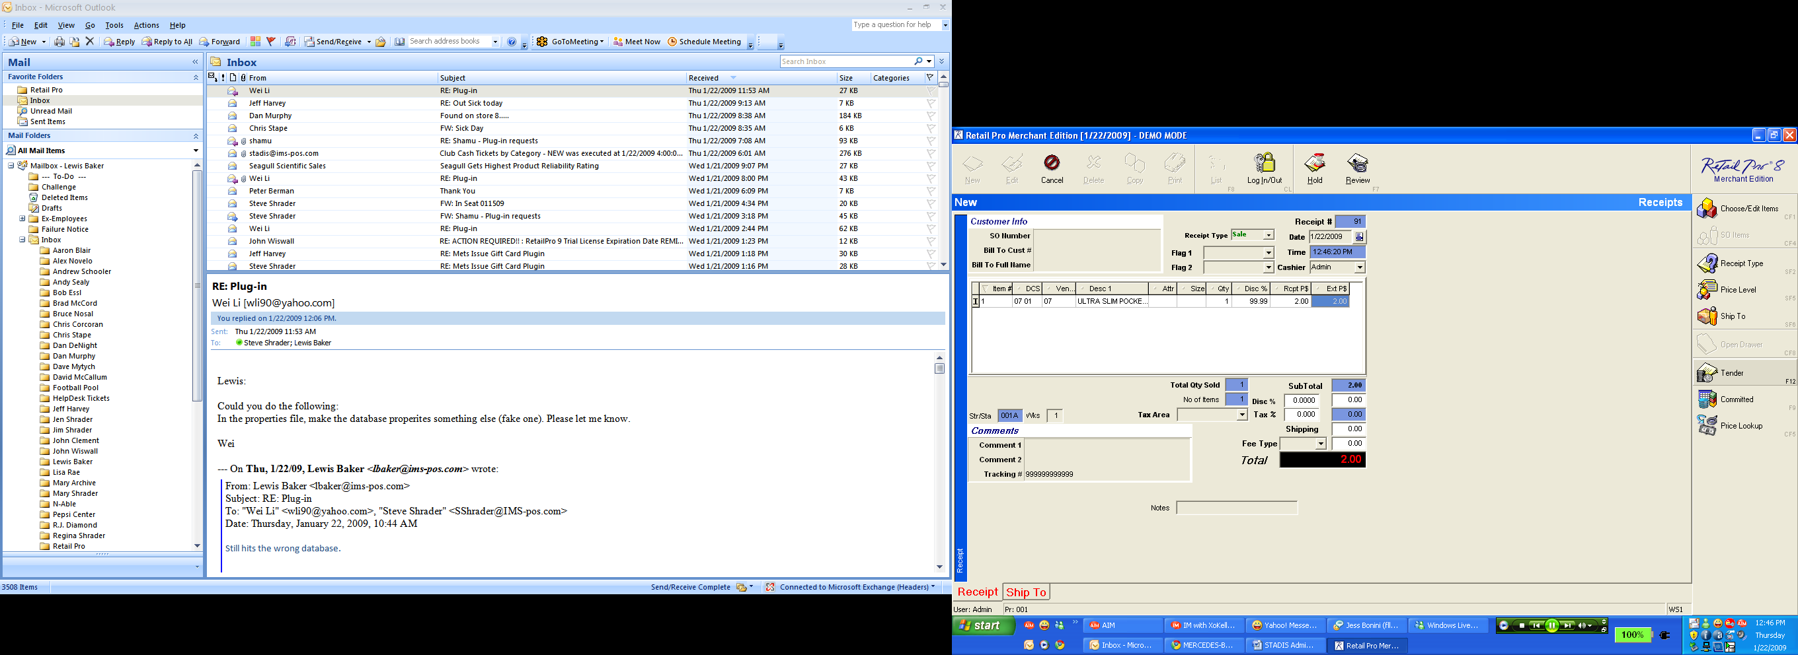

The next screenshot will show the stadisconfiguration.exe application. The setting for ‘Customer TicketOption’ will determine whether the pop-up appears for the added functionality for recording any ticket for any sale. This function is off by default ‘NO’, but can be turned on by typing ‘YES’ and then by clicking the ‘Update’ button.

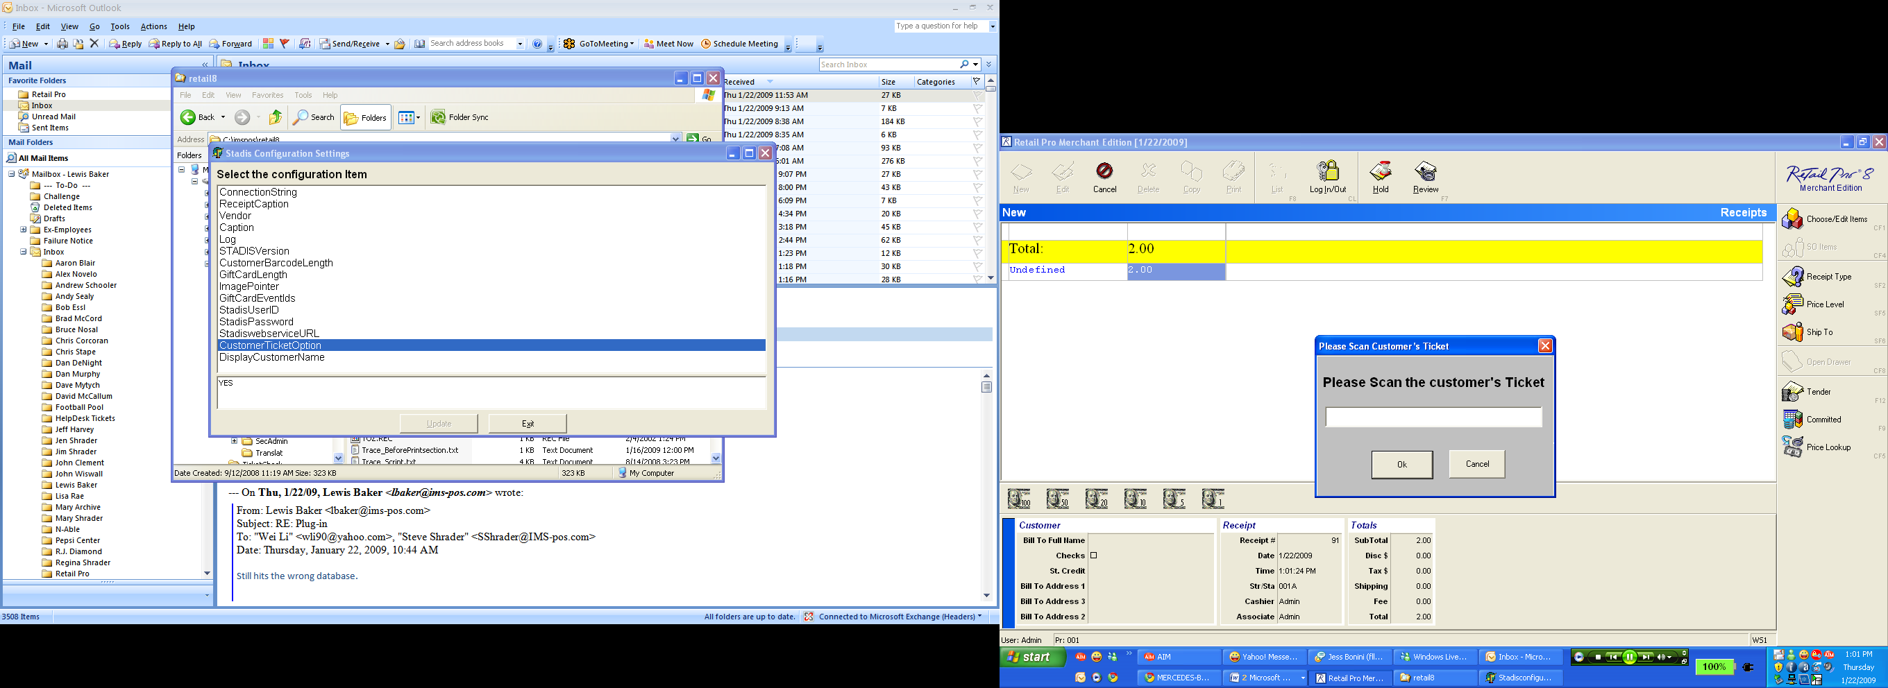

You may either scan the ticket when this box pops up, or hand-type the barcode by hand and either hit the ‘enter’ key or click on ‘ok. The ticket does not have to have value to be used. If there is no ticket, simply clicking cancel will advance you to the tender screen.



Tendering will be done the same way as it was prior to the installation of the plug-in, however there will be an added button on the right-hand side for choosing a STADIS-based tender.

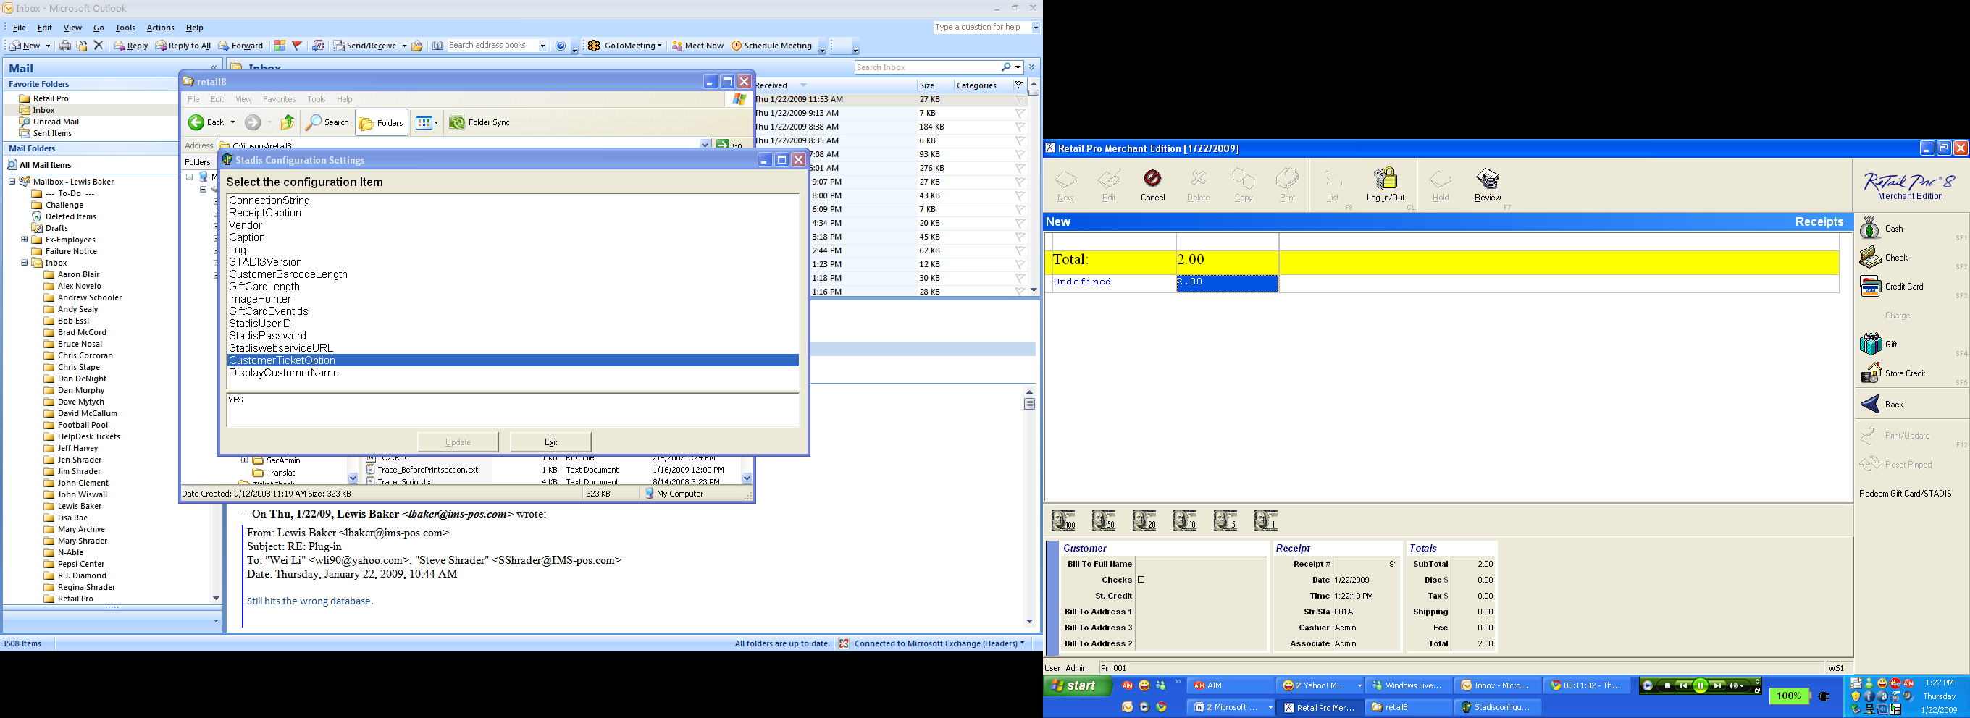

In the example above, you can see that it is titled “Redeem Gift Card/STADIS”. This can be changed in the stadisconfiguration.exe application as seen below. Changing the verbiage and hitting ‘Update’ will change how the button is labeled on the tender screen.

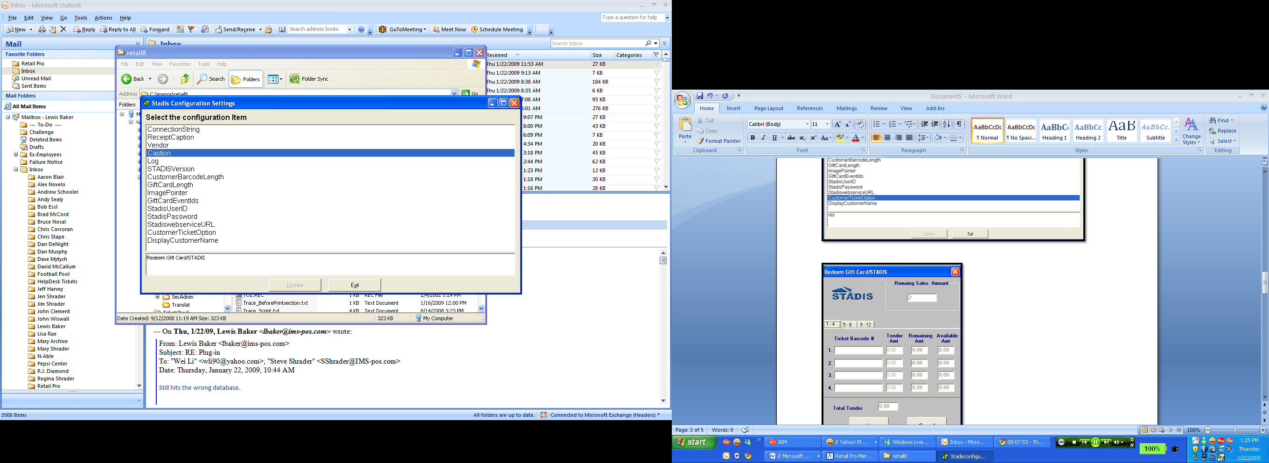

If using a STADIS-based tender, clicking the button on the right will bring up another pop-up box, as seen below. This plug-in allows for up to 12 tenders to be used at once.

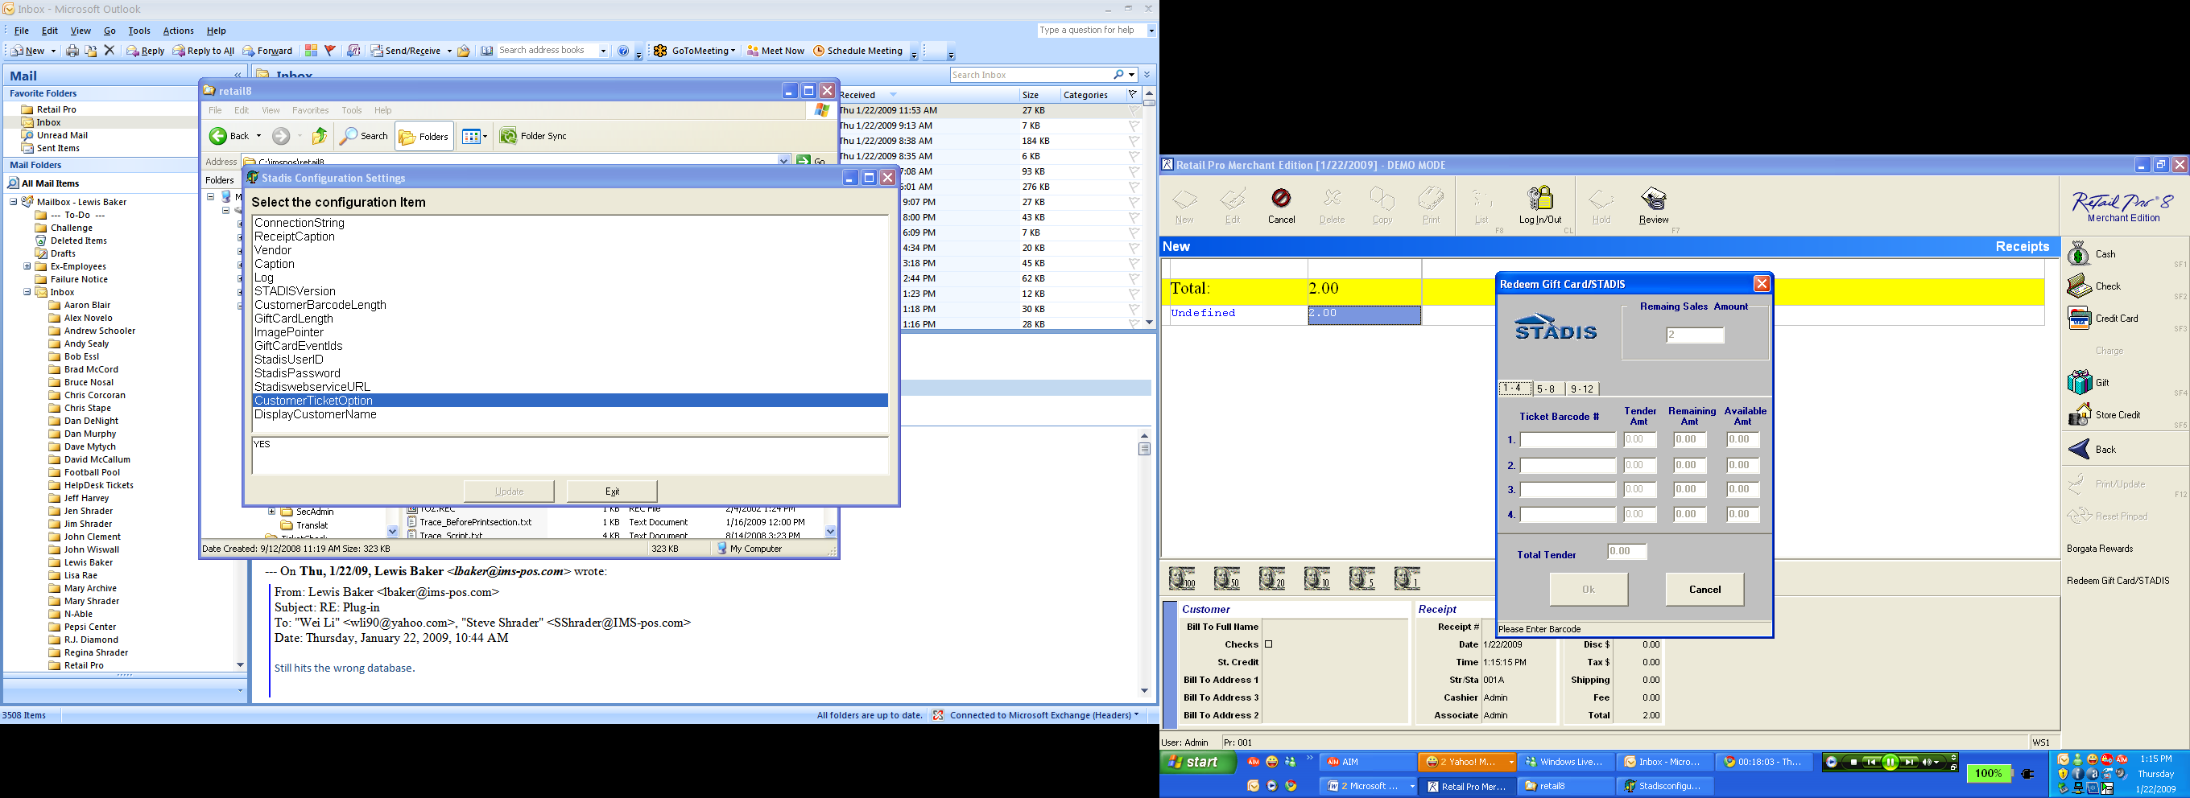

In the example below a ticket with an initial value of $421.81 was used to pay for a $2.00 sale. The last 4 digits of the tender are displayed as well as the tendered amount and remaining amount for the tender. Tenders may either be scanned in or hand-typed as needed.

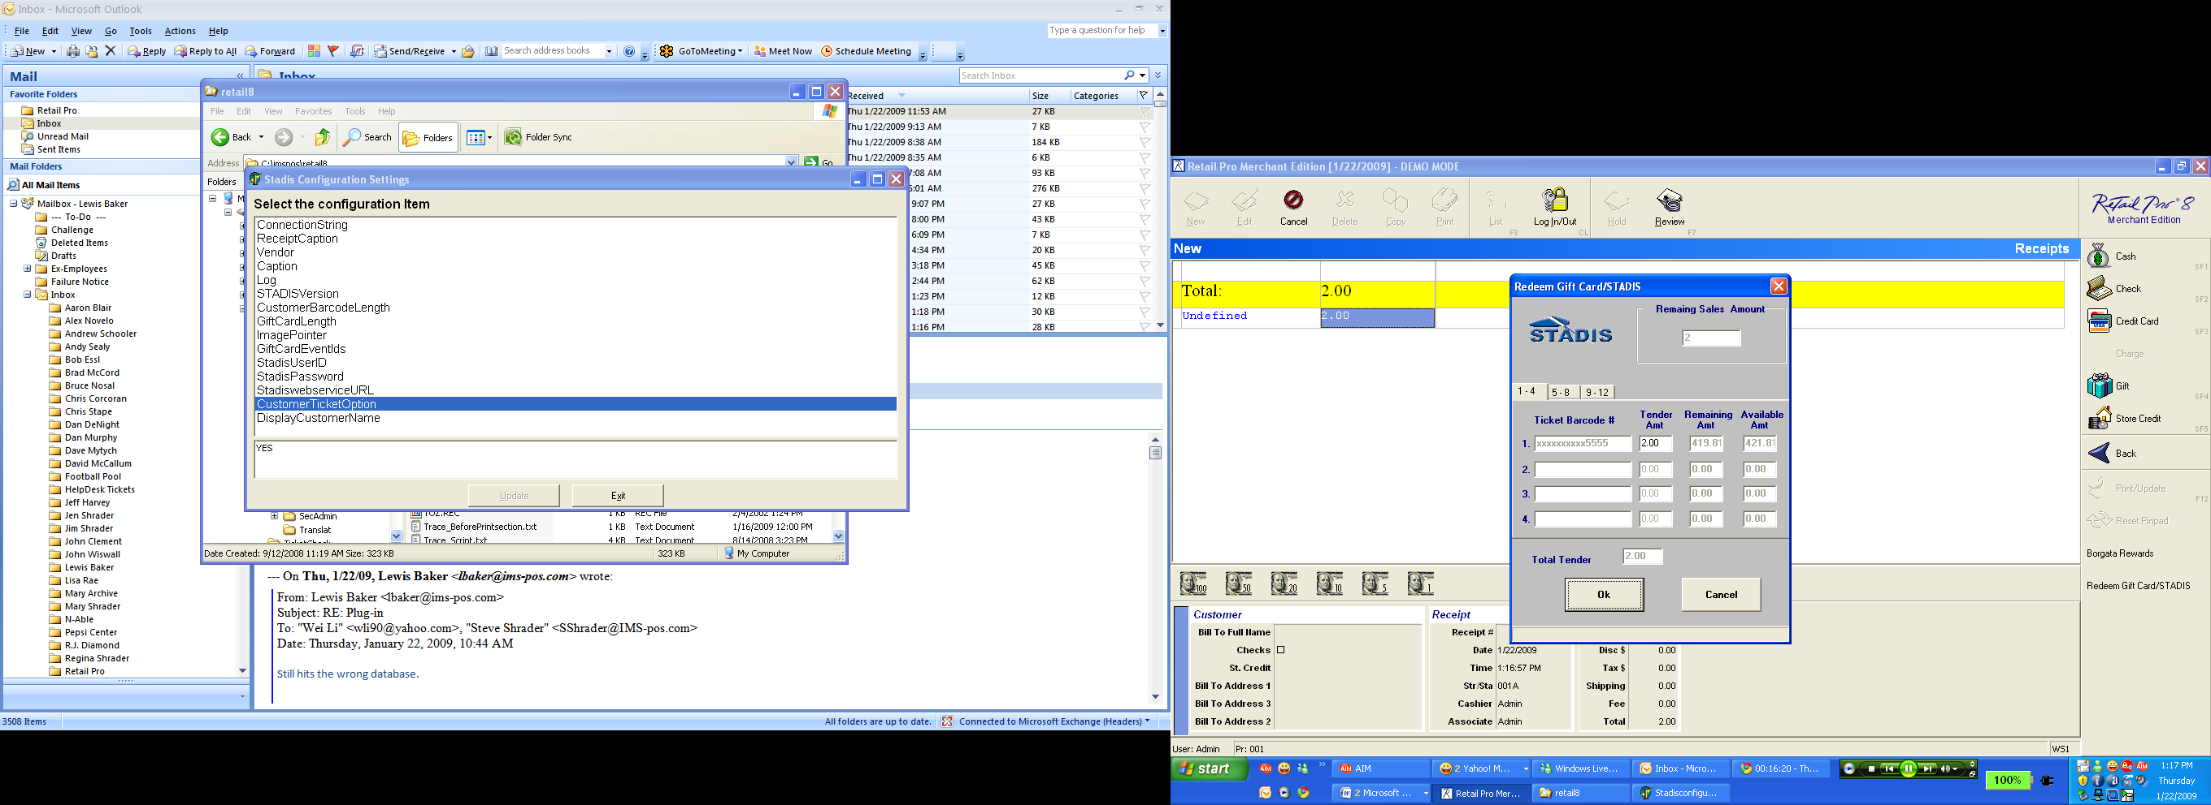

The example below is a good representation of a customer wanting to split the sale between multiple tenders. Simply entering one tender and clicking in the ‘tender amt’ field and changing the tender will allow only that amount to be deducted from a ticket. A second tender can then be entered for either the remaining value or whichever value the tender-holder would like.

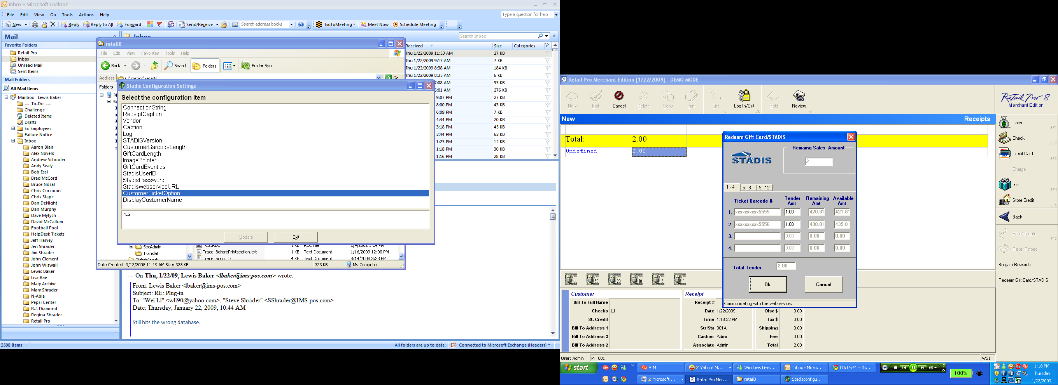

The tender will have the description of ‘TICKET’. It cannot be edited, but it can be removed by either clicking on the tender or hitting the ‘Delete’ key, or by changing the amount to ‘0.00’ and hitting the ‘Enter’ key. Clicking ‘Print/Update’ or hitting the ‘F12’ key will finalize the sale.

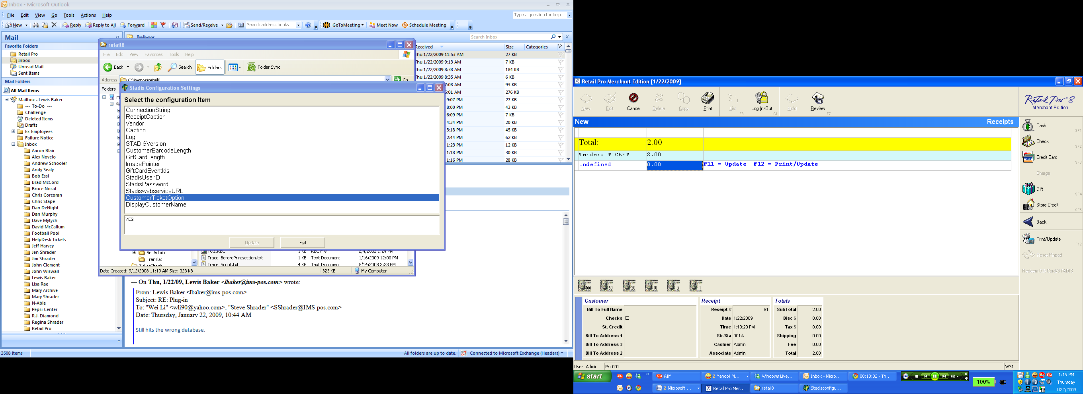

##### Procedure for Issuing a STADIS-Based Tender

The plug-in for issuing Gift Cards is located on the right side of your Retail Pro receipt screen.

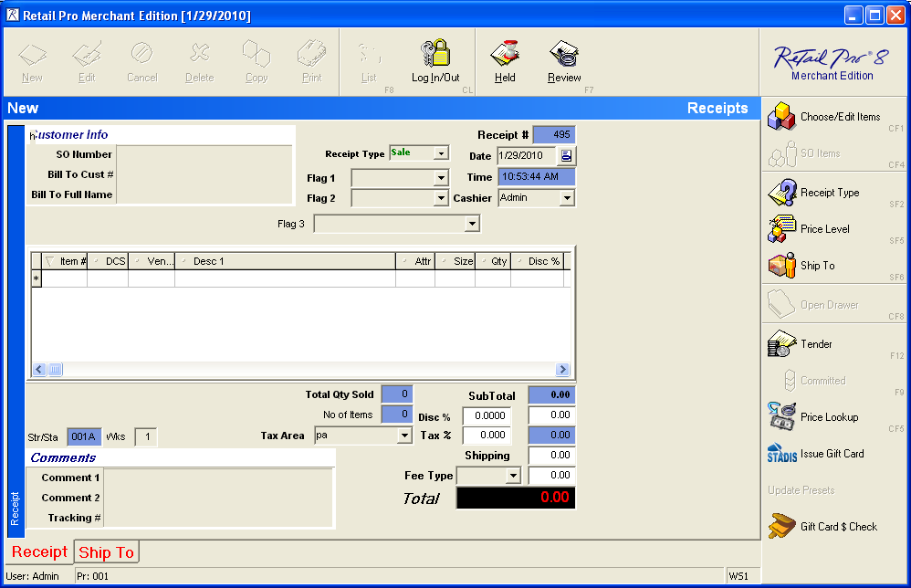

You are able to issue up to 12 cards at one time. The image displayed in the upper-right of the Issue Plug-in can be changed through the STADISConfiguration application, along with other features.

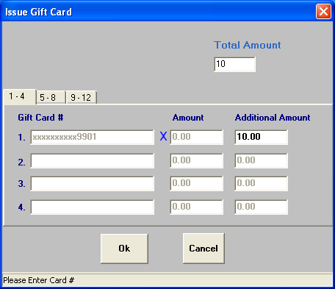

The “Change” is given as a Gift Card and the transaction can be completed as any other transaction.

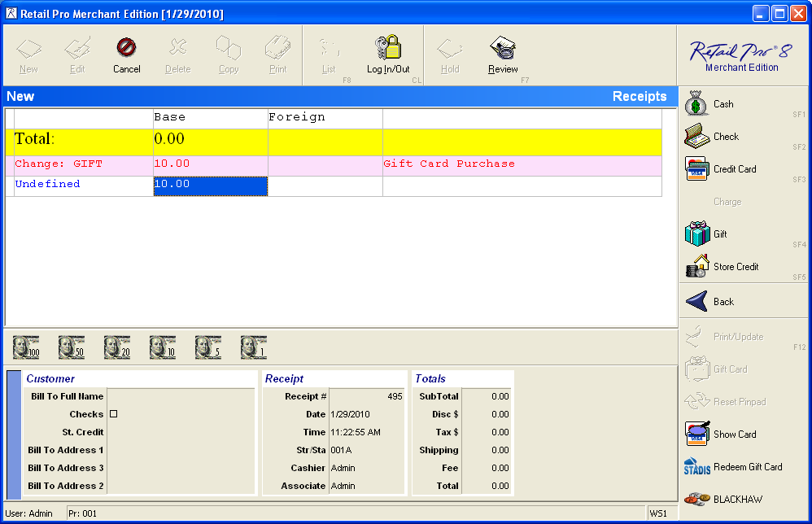

## Receipt Design

Upon completing a transaction in which a STADIS tender was either Issued or Redeemed, the receipt will display a small amount of detail regarding the STADIS transaction. In the following screenshot, you will see tender detail at the bottom of the receipt. It will give you detail on any cards issued or redeemed on any given transaction. The header of the detail may be changed in the STADISConfiguration application.

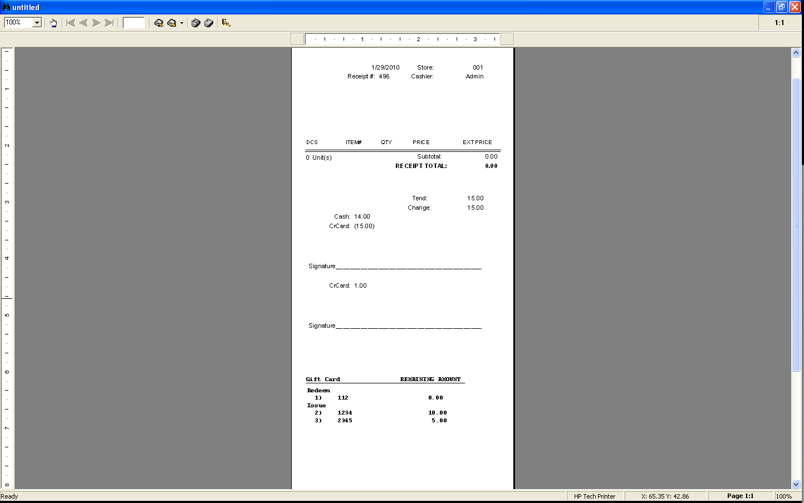

This detail is provided through the install process and will create a new receipt design in your workstation preferences. To utilize the additional features of STADIS, we recommend that the design provided (40 Col STADIS) be set as the default design and that the design is edited to suit your needs or to resemble your current receipt design. That can be accomplished in the Document Designer of Retail Pro.

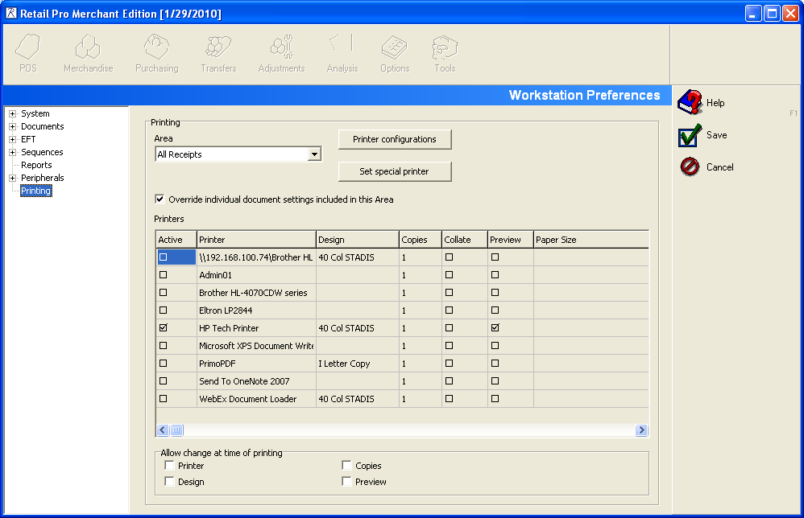

## Balance Check Program

The Balance Check Program is installed automatically when running the install batch file discussed earlier in this documentation. It is used to check the balance and history of any STADIS tender. The button to launch the program is located on the receipt screen and can be removed or modified by editing the Usermenu.ini file in the RPRO directory.

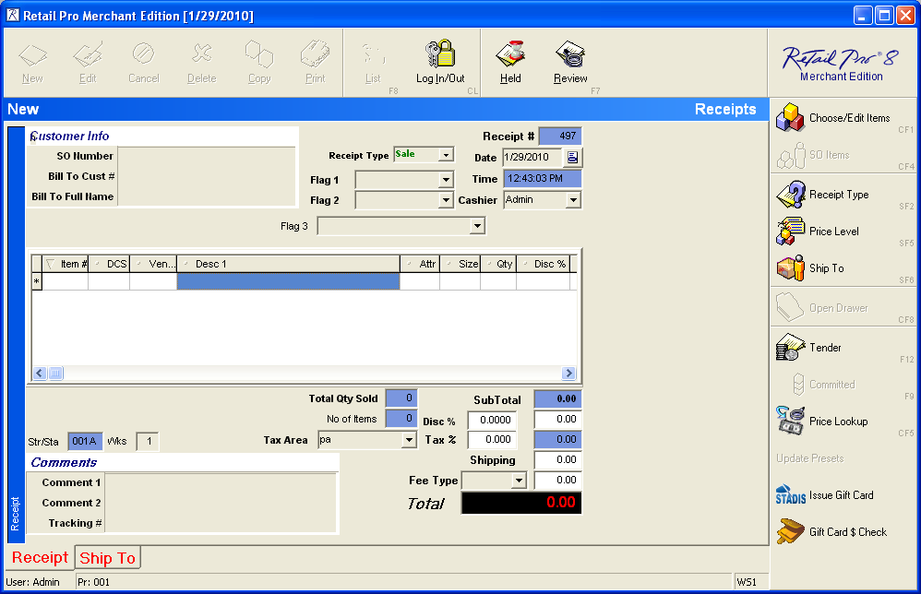

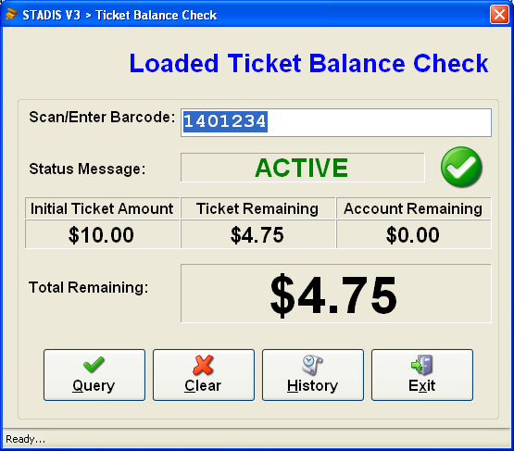

“Account Remaining” is used in “Mixed-Mode” applications. If you are unaware if you have the ability to load value onto accounts, please contact International Micro Systems for more information. The “History” button is used to show any activity that has occurred for the STADIS tender that was queried.

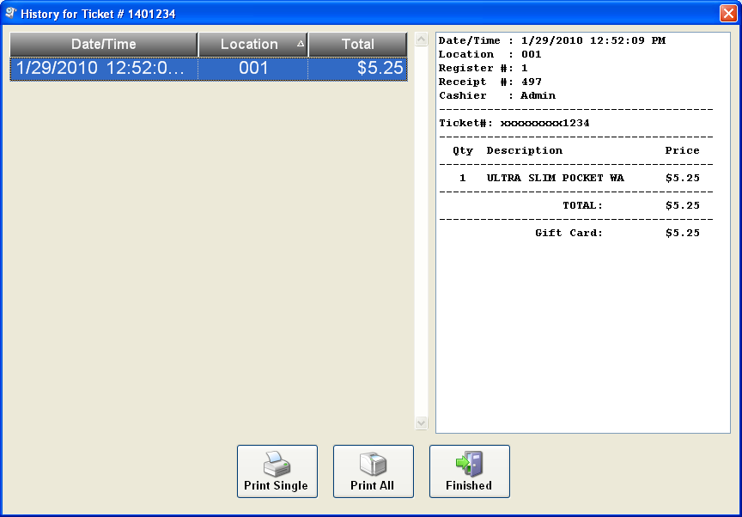

In the event that a customer would like to see any or all transactions for any given STADIS tender, the associate my click any of the previous transactions on the left and click “Print Single”. Similarly, clicking “Print All” will print all transactions on one easy-to-read receipt. Settings to print are stored in the StadisBalanceCheck.exe.config file and the location was discussed earlier in the documentation.

## Configuration Information for Retail Pro Plug-in.

Server name: ______________________________________

Server IP Address: ______________________________________

Alias for Gift Cards if any: ______________________________________

Alias for Loaded Tickets if any: ______________________________________

Number of Digits for Ticket Barcode: ______________________________________

Number of Digits on Gift Cards: ______________________________________

Local Path to Retail Pro: _________________________________________________________

Allow Reloading of Gift Cards(Y/N): _______________

Allow Issuing of New Gift Cards(Y/N): _______________

Allow Reloading of Value Back onto STADIS Tender upon Reversal of Transaction(Y/N): _______________

Are the Machines Always Running with Administrative Rights(Y/N): _______________

Are there are other plug-ins, applications or extenuating circumstances that may prohibit or inadvertently effect the installation or operation of STADIS or other Retail Pro Plug-ins? This may include network restrictions, user rights or otherwise._______________________________________________________________________________________________________________________________________________________________________________________________________________________________________________________________________________________________________________________________________________________________________________________________

